Avic Xi’an Civil Aircraft Co., Ltd

MA600 Aircraft Stowage Management System User Manual

February 2022

Catalogue

1 Documentation and reference 1

2 Sytem enviorment requirement 2

3 System operating instructions 3

3.1 System login 3

3.2 System administration and initialization 4

3.2.1 User Management 5

3.2.2 Orle Management 6

3.2.3 Menu permission management 8

3.3 Weight ratio management 8

3.4 Basic aircraft information management 9

3.5 Aircraft registration information management 11



3.6 Aircraft Dynamic information management 12

3.7 Data anlysis and statistic 17

1. Documentation and references

* **Documentaion**

This document is the “MA600 Aircraft Allocation Management System” user manpual of AVIC Xi’an Civil Aircraft Co., Ltd (“AVIC Xi’an Civil Aircraft”), including the system operation instructioins for dispatchers, auditors and system administrators, business management and supervisor.

* **Write Gist**
* The program proposal of MA600 Aircraft Allocation Management System；
* The business solution of MA600 Aircraft Allocation Managemnet System；
* **Concepts and Terminology**
* Allowed Traffic Load，最大业载
* Total Traffic Load，实际业载
* Under Load，剩余业载
* Dead Load，固定负载
* Load Sheet 载重表
* Balance Chart/ Manifest 平衡表
* MTOW - Maximum Takeoff Weight，最大起飞重量
* MZFW – Maximum，最大无油重量
* MLW – Maximum Landing Weight 最大着陆重量

1. System Enviorment Requirements

Enviorment requirements of system hardware：

|  |  |  |
| --- | --- | --- |
| Hardward | Configuration parameters | Note |
| CPU | 8 cores (2.4GHZ) and above |  |
| Memory | 16G and above |  |
| Hard Disk | 200G and above |  |

Enviorment requirements of system software:

|  |  |  |
| --- | --- | --- |
| Software | Versions and parameters | Note |
| JAVA | JDK - V1.6 |  |
| Broswer | Chrome V40.0 and above |  |
| Operating System | Windows 7/10 and above |  |

1. System Opearting Instruction
   1. System Login

Opening Google (Chrome) browser, the user need to input <http://127.0.0.1> in the address bar, (note： For remote access, enter the IP address of the server) and press the enter key. Then the user login page will be displayed, as shown in the figure:

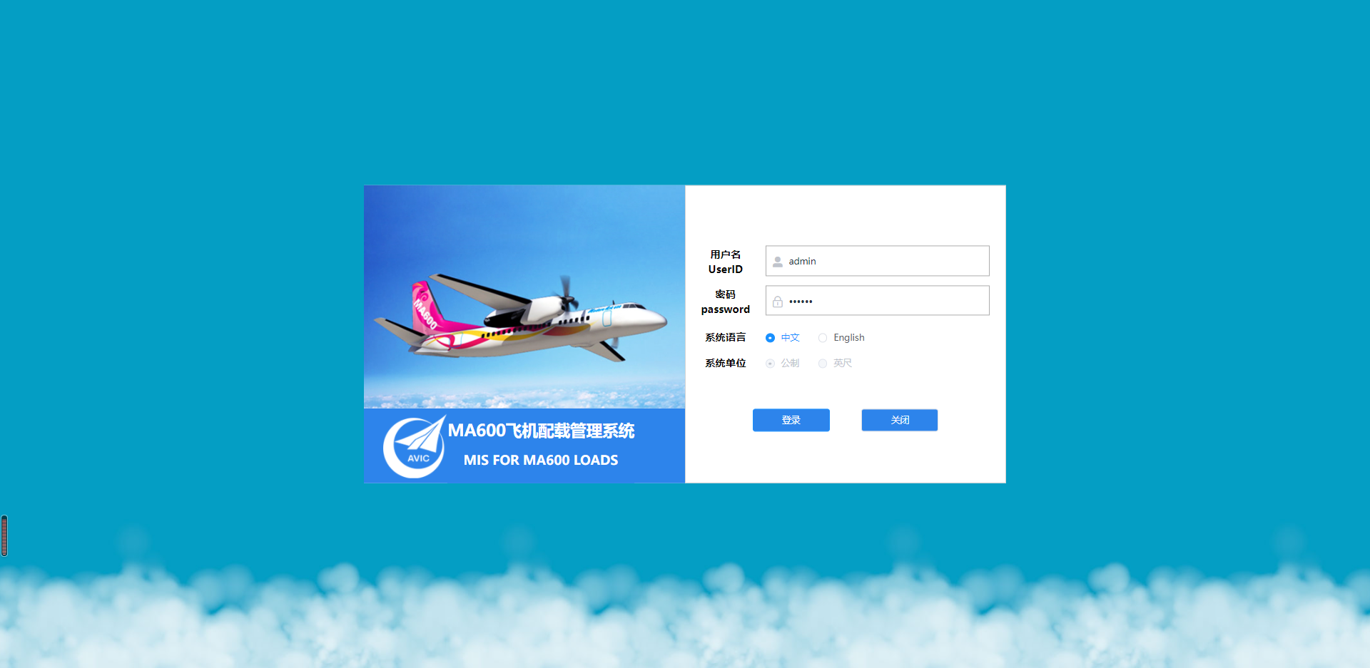

*Note： The “System Language” and “System Unit” options are not selectable, which are setting in the background configuration file after the system is installed.*

After entering the username and password, the user need to click the login button and the system will verify user account. After valiadation, the dashboard will be displayed, as shown in the figure:

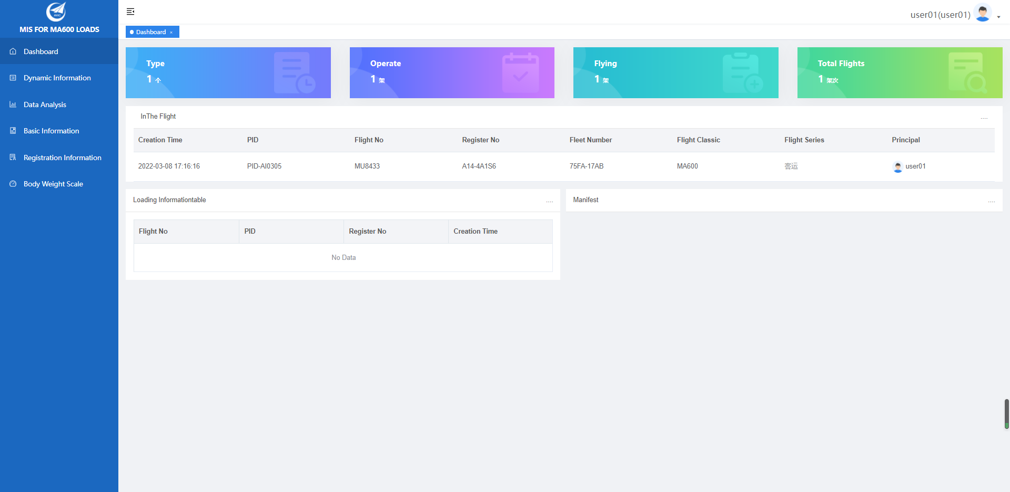

On the dashboard, there are the function menu on the left, the display data area in the middle, and the currently logged-in user information and the operation option of 【Log Out】 at the upper right, as shown in the figure:

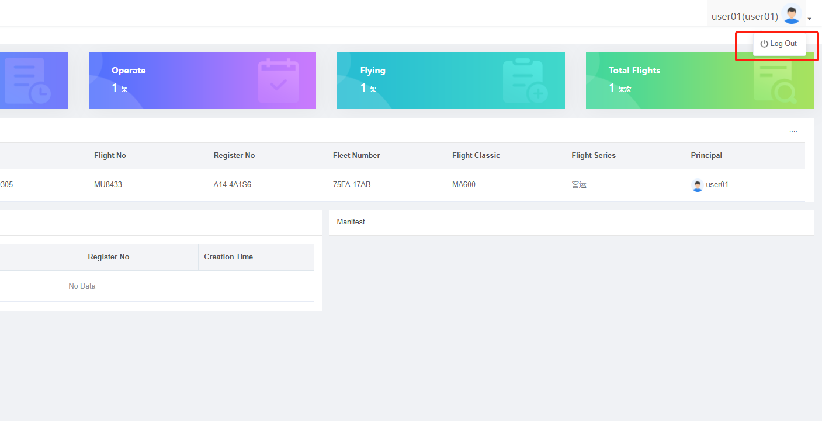

* 1. System administration and initialization

After the system is installed, the admin account will complete system management and initialization, seeting roles, users and permissions in the system included. The operations are basically same, whether completing the system initialization before first use or executing operations in the process of subsequent system operation and maintenance.

* + 1. User Management

User management mainly includes user information maintenance and management function, including adding, modifying, deleting, disabling and resetting passwords.

After logging into the system, the admin select 【System Administrator】-【User Information】 in the left menu tree to enter the main interface,as shown in the figure:

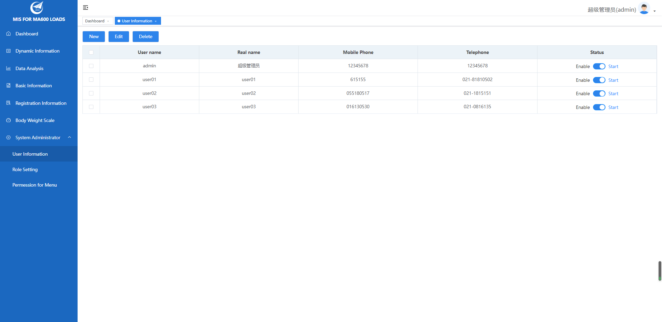

Click in 【New】 (or 【Edit】) on the tolbar of list top left to enter the interface of add the user (or edit the user), as shown in the figure.

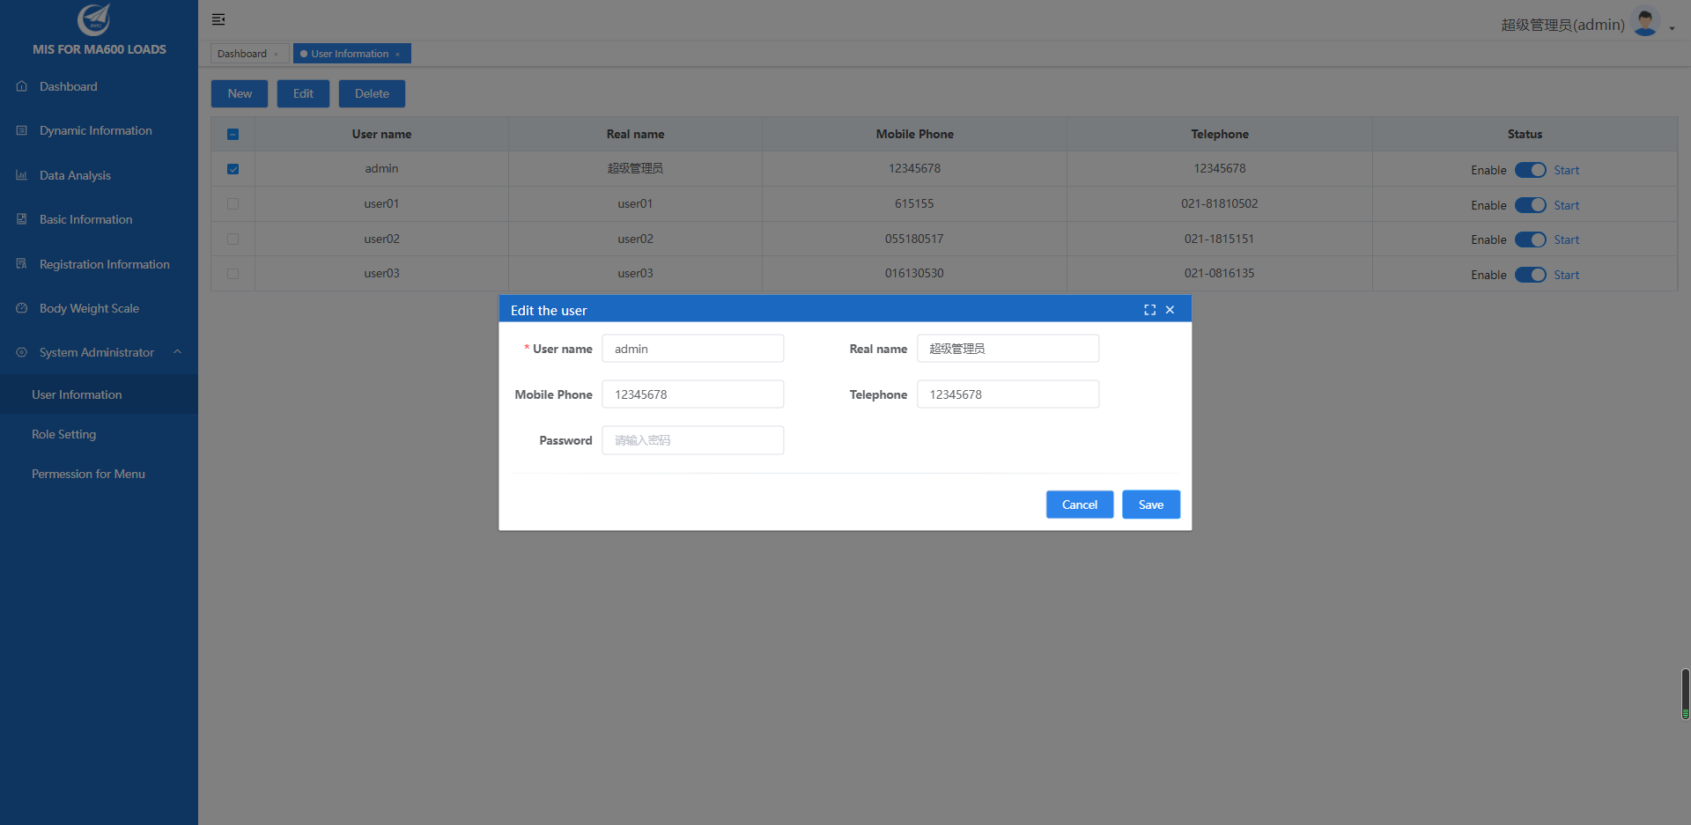

After entering the username, real name, mobile phone, telephone password (default: 123456), click 【Save】 to complete add (or edit).

Select the user in the list and click the 【Cancel】 button on the toolbar to delete the user.

In the status column, admin can enable or disable user. And the disabled user can no loger log into the system.

* + 1. Role Management

Role management includes maintenance of role definition and role members. After logging in to the system, the admin selects 【System Adminisitrator】 - 【Role Setting】 in the left menu to enter the main interface of role management, as shown in the figure.

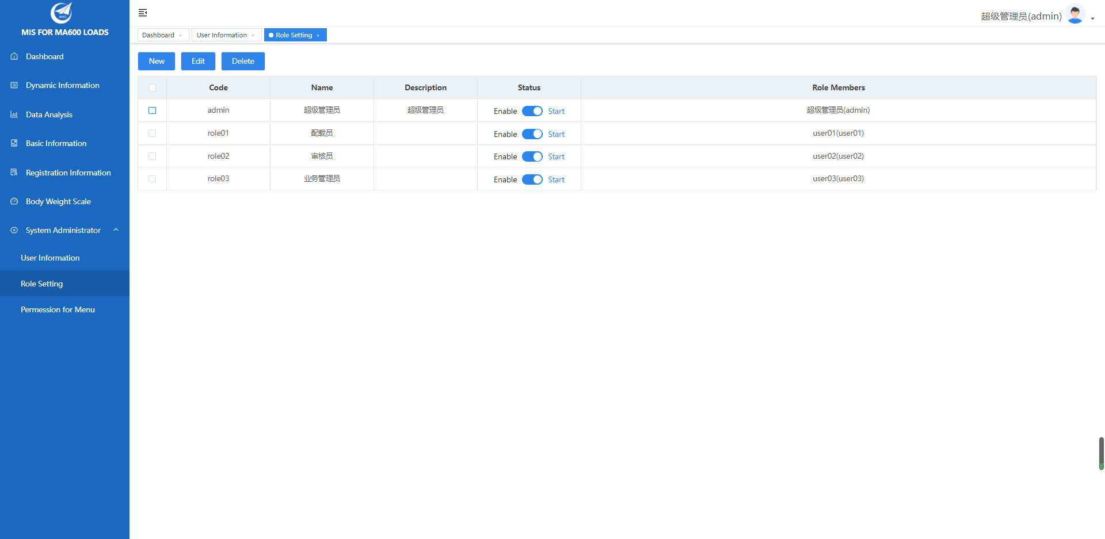

Click the 【New】 or 【Edit】 button on the toolbar to add or modify the orle, as shown in the figure.

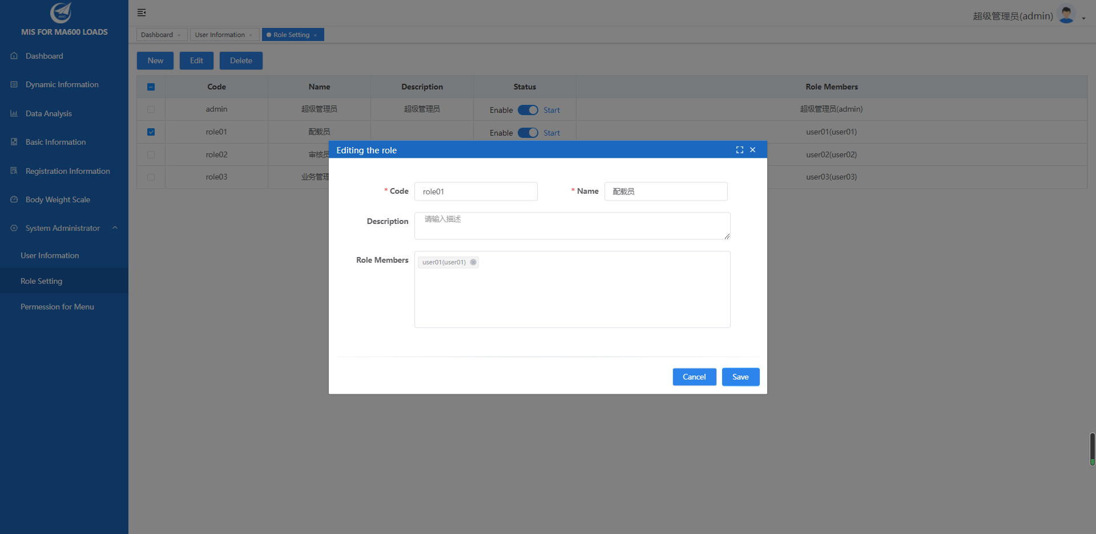

Note: Selecting users in the “role members” column to add them as role members, this selection is allowed to inquire and locate users by fuzzy characters.

In the “status” column of the role list, enabling or disabling the role definition can be performed.

* + 1. Menu Premission Management

Menu Premission Management is mainly assigning the acess rights of system menue to different roles and users based on its business requirements; admin can select 【System Administrator】 – 【Premission for Menu】 from the left menu, as shown in the figure.

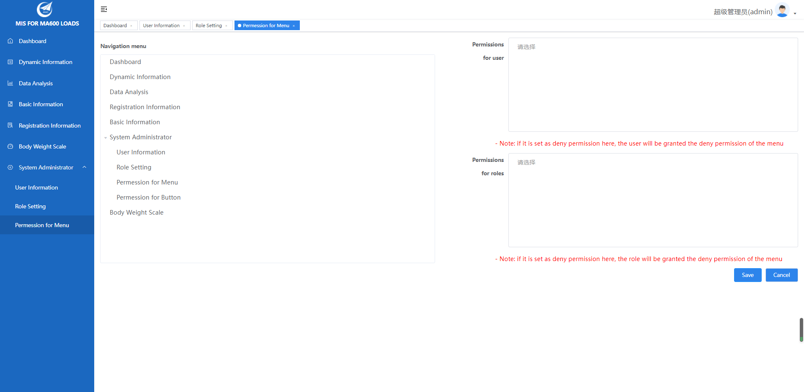

On the left is “navigation mune tree” interface, and on the right is authorization operations interface. It should be noted that the exclusion permission setting is adopted, which means all users or roles have the permission to access all menus by default. If someone is restricted from using one menu, the user needs to select corresponding mune and add the user or role to the “Permissions for user” or “Permissions for roles” column.

* 1. Weight Ratio Management

Weight ratio management mainly maintains the standard unit weight of personnel including adults, children and infantst, so that the weight can be calculated from the number of people in the subsequent calaulation of the center of gravity (Note: the weight ratio here includes the carry-on luggage of persons).

Weight ratio management belongs to the scope of business management settings. The admin can set up a “business administrator” role and assign the function authority such as Body Weight Scale”, “Basic Information”, “Registration Information” to the business administrator.

The business administrator can log into system, and then select 【Body Weight Scale】 from the menu tree on the left, as shown in the figure.

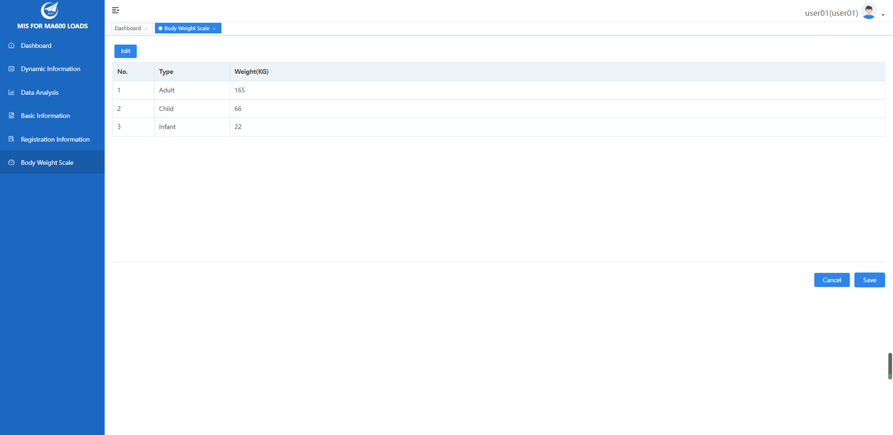

First, click the 【Edit】 button on the toolbar to edit the “weight”. After that, click the 【Save】, then the maintaince of the weight ratio is completed.

* 1. Basic Aircraft Information Management

The function of Basic Information is mainly to definite information about the airfract type, the service number （service classification code）, aircraft distinguishing and load limitation. This operation usually is charged by the “business administrator”.

The “business administrator” enters the management page by selecting 【Basic Information】 on the left mune tree, as shown in the figure:

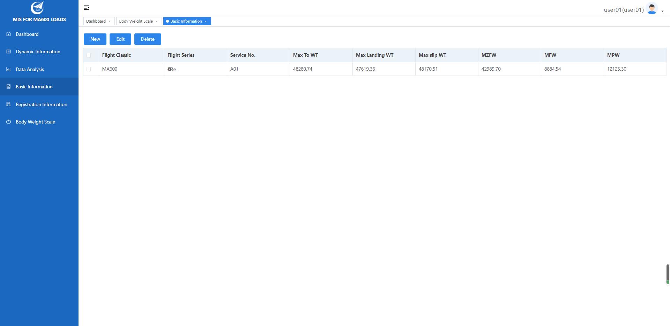

In this page, operation of adding, editing, deleting the basic information can be allowed. Click the 【New】 button to enter the add page, as shown in the figure:

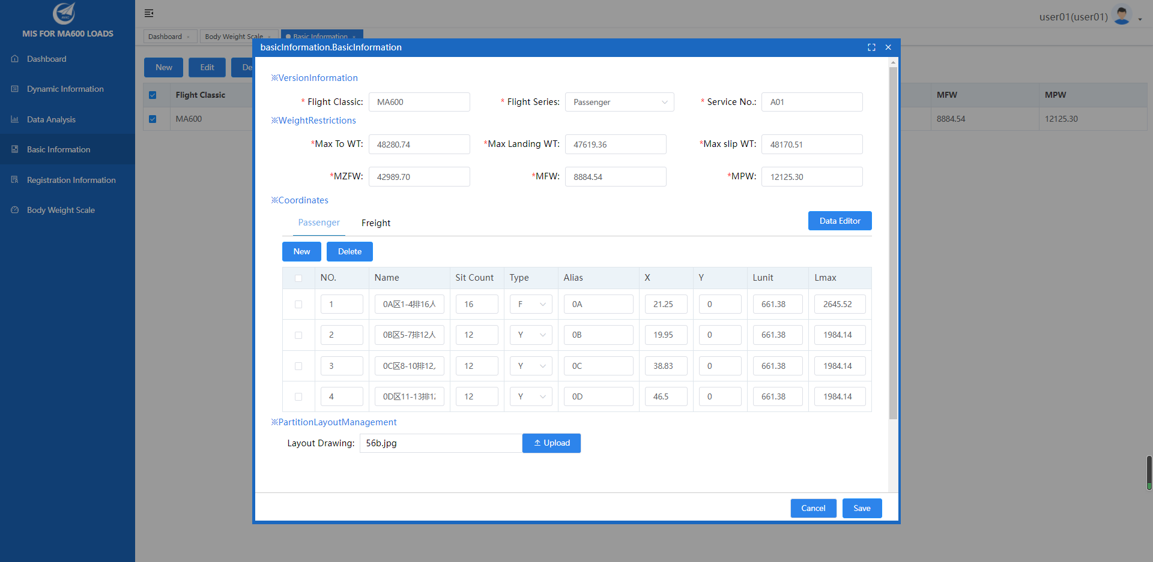

Definition of aircraft basic information:

1. The business administrator inputs aircraft information about type, series, service number in the 【Flight Classic】 column and inputs the Maximum Takeoff Weight, Maximum Landing Weight, Maximum skidding Weight, Maximum Zero Fuel Weight, Maximum Fuel Weight, Maximum Load Weight in the 【Weight Restrictions】 column.
2. Definition the name, type, alias, coordinates, Lunit and Lmax of Passenger and Freight in the 【Coordinates】 column.
3. Open partition information in text form to copy, stick, edit by 【Data Editor】.
4. Upload the aircraft layout diagram of the aircraft mode to the 【Partition Layout Management】 column.
5. Last, click the 【Save】 to complete the creation and edit of aircraft basic information.
   1. Aircraft Registration Information Management



Aircraft registration information is registered by business administrator after the aircraft manufacturer delivers the aircraft to the airline.

The business administrator enters the main management page by selecting 【Registration Information】on the left menu tree of the system, as shown in the figure.

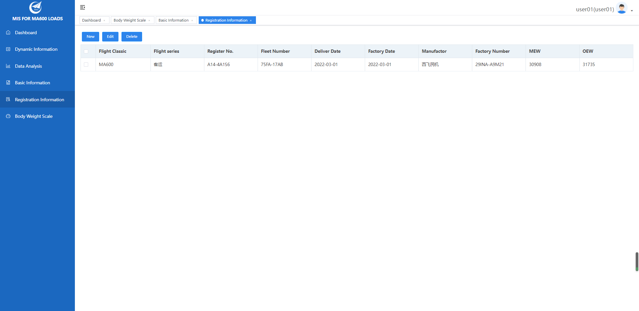

Click the 【New】 or 【Edit】 button on the toolbar to add or modify the aircraft registration information, as shown in the figure.

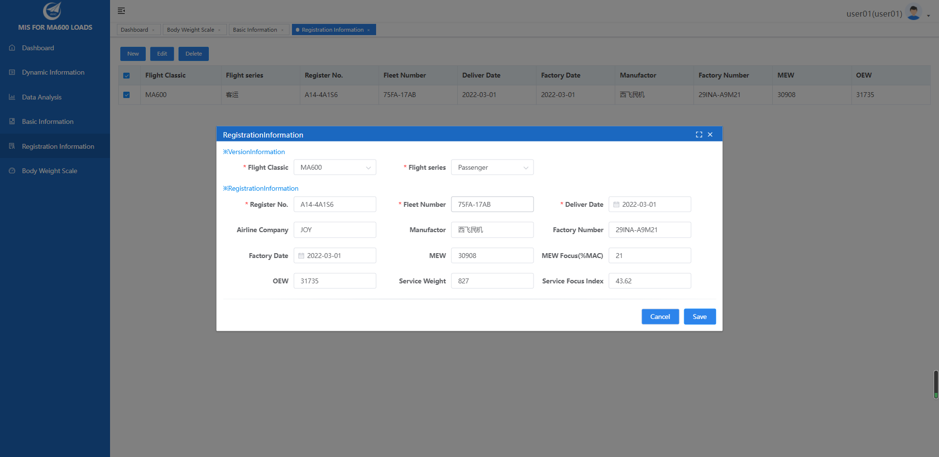

Business administrator selects the type in the type information column which added in aircraft basic information and selects the corresponding series; in the registration information column, fills with the register number, deliver data, airline, manufactor, manufacturing empty weight, manufacturing empty center of gravity (% MAC), using empty weight, ，corporate aircraft weight, business gravity index, etc. Click the 【Save】 button to finish adding or editing the aircraft registration information.

* 1. Aircraft Dynamic Information Management

The aircraft dynamic information management is the information recorded management of each flight in the operation process of airline, and the corresponding aircraft stowage information table and electronic manifest can be generated according to the filled flight information system. It is the dispatcher add or edit aircraft dynamic information management and the auditior freeze the information.

The dispatcher selects the 【Dynamic Information】 in the left menu tree to enter management main page,

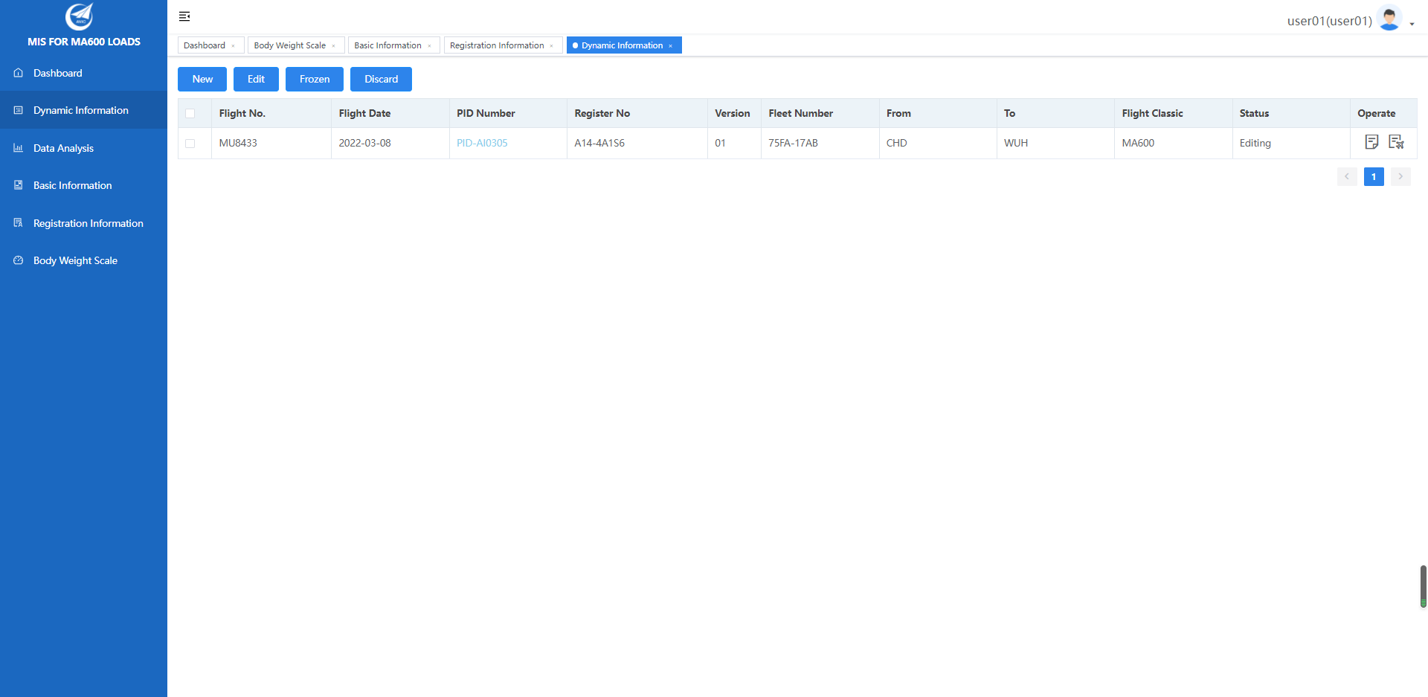

Dispatcher can click the 【Add】 and 【Edit】 buttons on the toolbar above the list to add and edit flight information, click to enter as shown：

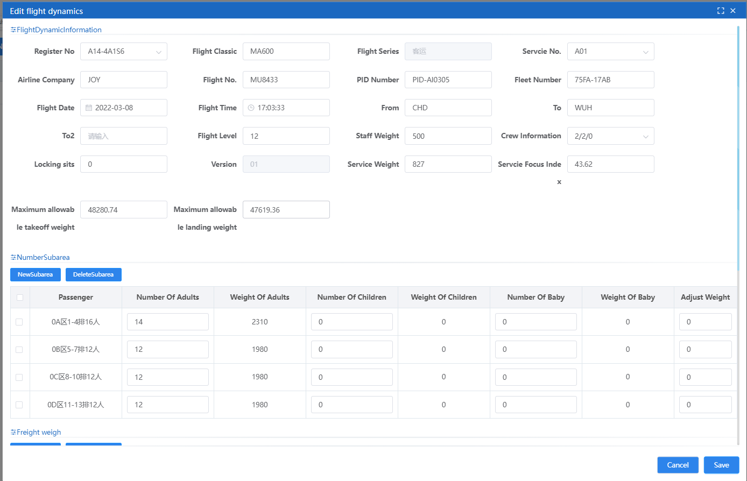

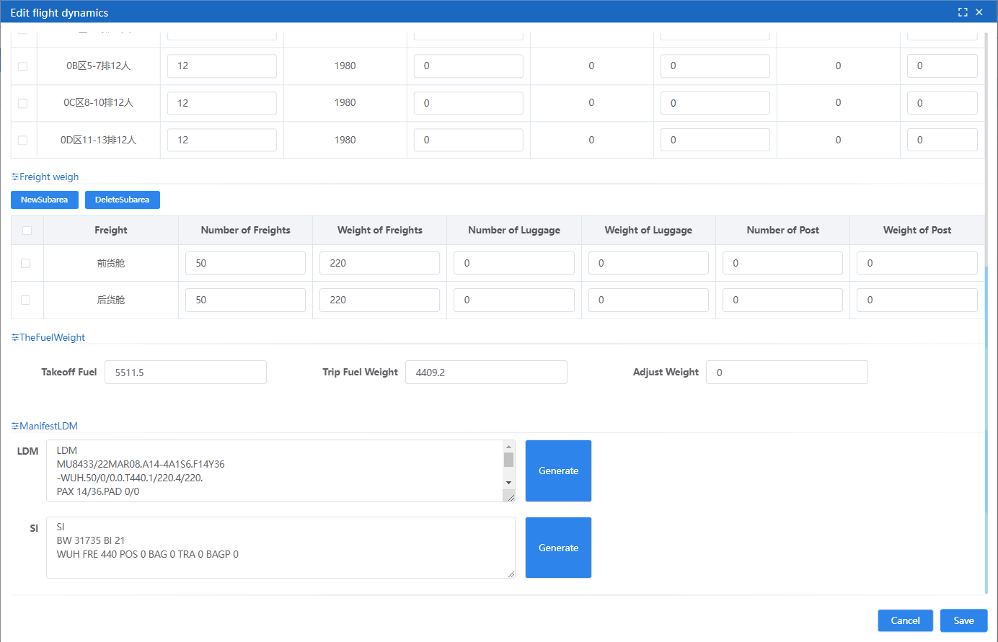

Specific operating instructions are as follows：

1. The dispatcher inputs the register number in the 【Flight Dynamic Information】, and the system automatically displays the information of flight classic and flight series.
2. After selecting the “service number”, the list of cabin partition information will be displayed for editing according to the selection.
3. Dispatcher continue to input information about airline, flight number, fleet number, flight time, departure location(from), destination(to), flight level, crew information, service focus inds, and fill in the maximum takeoff weight and maximum landing weight based on various conditions such as weather.
4. Fill in “destination 2(To 2), the load information of the stopover section is required when the stopver happened.
5. According to the definition of the passenger, the dispatcher fills in the 【Number Subarea】 column with the partition loading condition.
6. According to the definition of the freight, the dispatcher fills in the 【Freight Weight】 column with the partition loading condition.
7. Dispatcher fill in the 【Fuel Weight】 column with takeoff fuel and trip fuel weight information.
8. Dispatcher clicks the 【Generate】 button in the 【Manifest LDM】 column to generate the “LDM” and “SI” information, and dispatcher can edit and modify them manually.
9. After completing the above content, click the 【Save】 button to fiinish the adding or editing operation of the dynamic information.

After the dispatcher finishes the information entry and saving, the auditor reviews the entered dynamic information of the aircraft, check the corresponding record on the list interface and click the 【Frozen】 button on the toolbar to freeze the dynamic information of the aircraft. (Note: the freezed data can 【Discard】 if data invalid, by this time the plane dynamic information records will rise).

In the preservation and freezing conditions, the dispatcher and the auditor can click the 【Generate the stowage information table】 and 【Generate electronic manifest】 button in the 【Operate】 column to generate the corresponding dispatch information sheet and electronic manifest

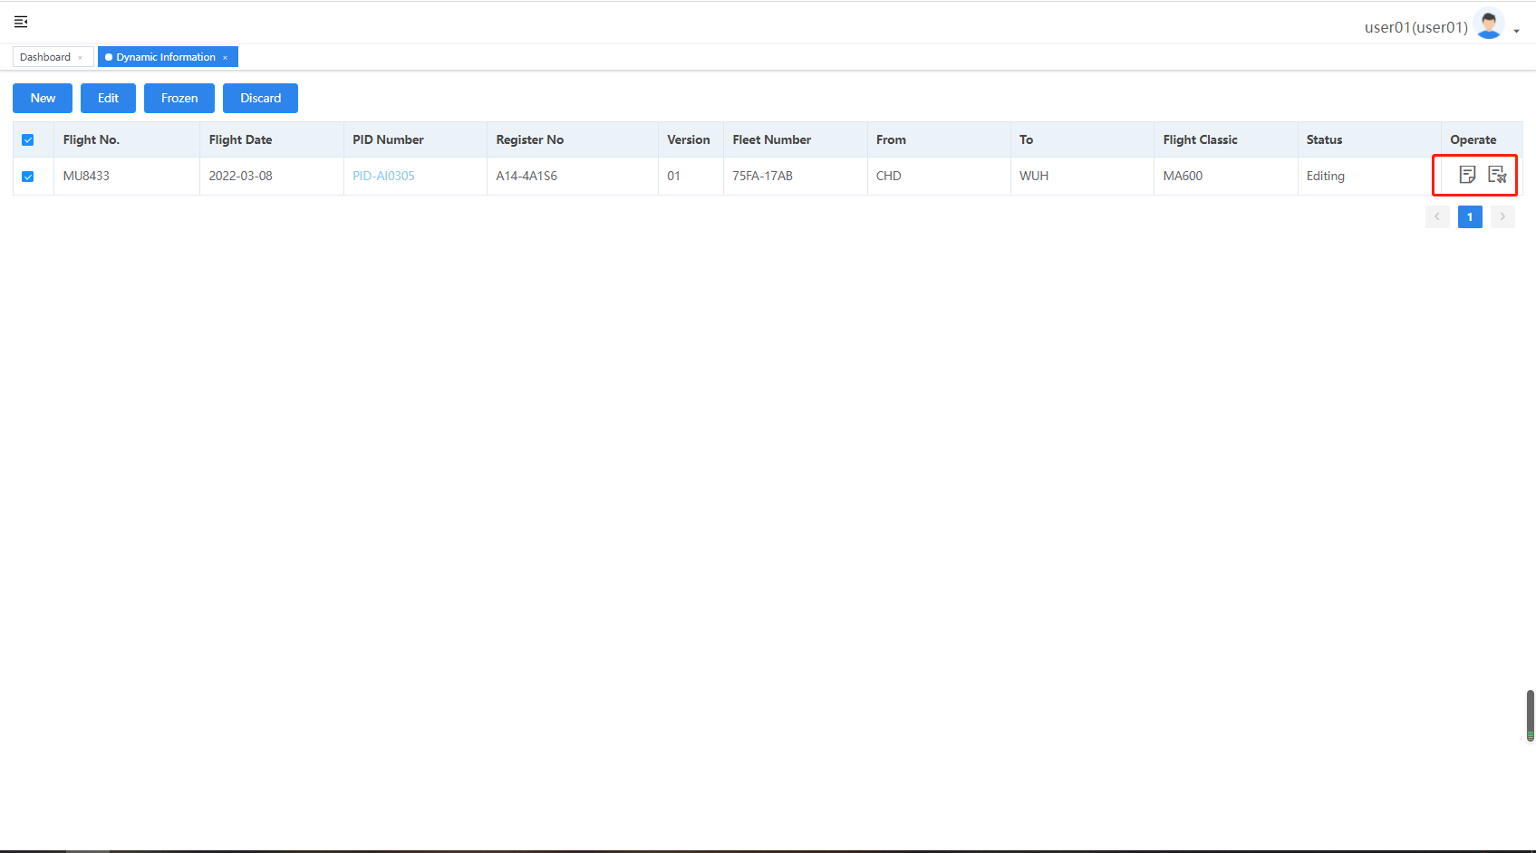

Click the Generate the stowage information table】 button, picture this:

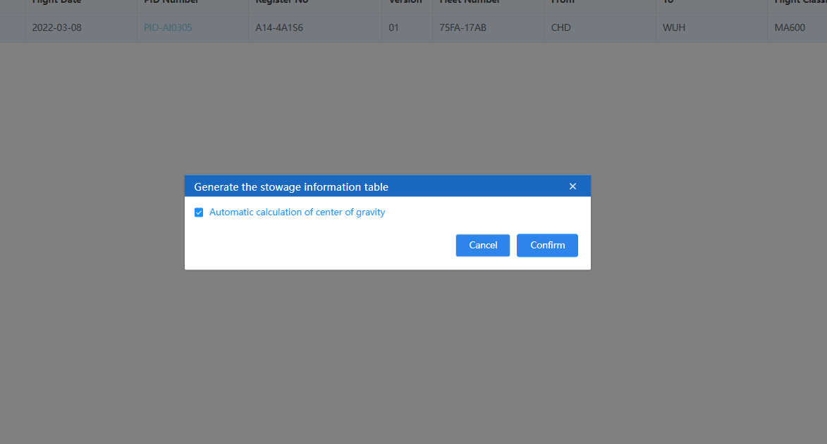

If the dispatcher and auditor select the option “Automatic calculation of center of gravity”, the system will show the stowage information table with load information and load center of gravity vertical line, othervise it will show the empty stowage information table, picture this:

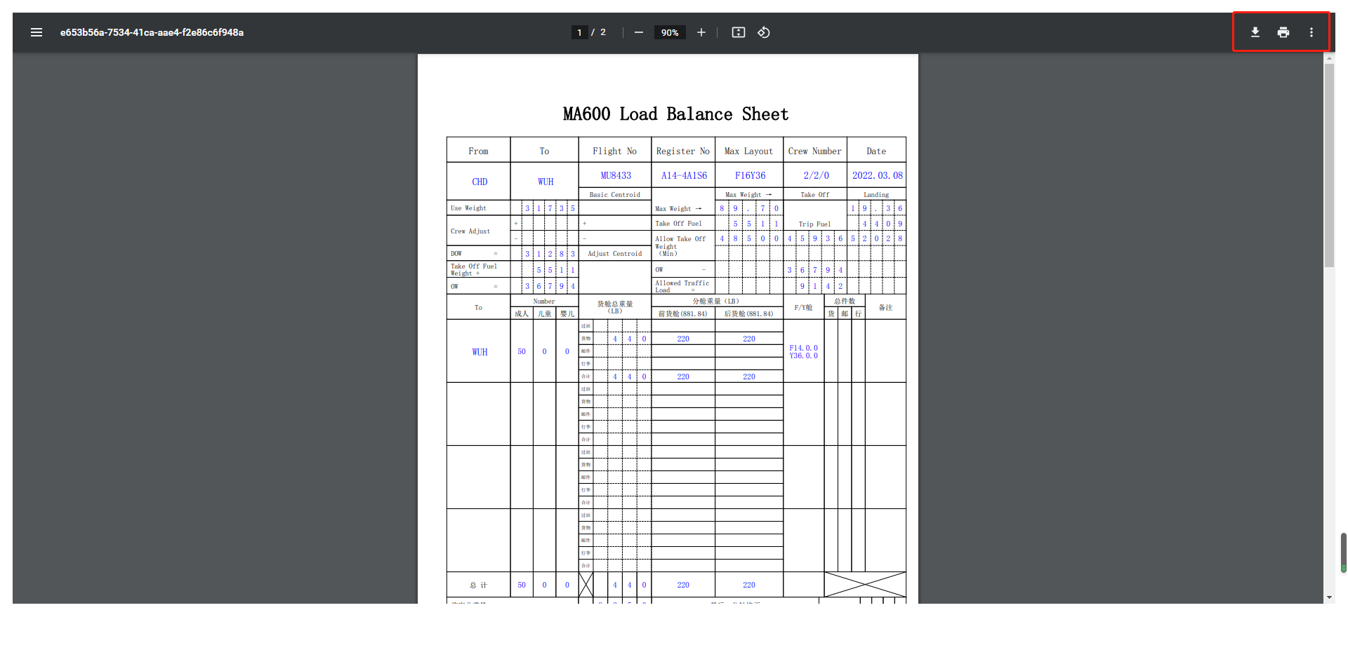

Dispatcher and auditor can print out the stowage information table by clicking download and print buttons in the upper right corner.

Dispatcher and auditor click on the 【generate e-manifest】 button, the system will automatically generate the corresponding e-manifest, and promputs the user to download, picture this:

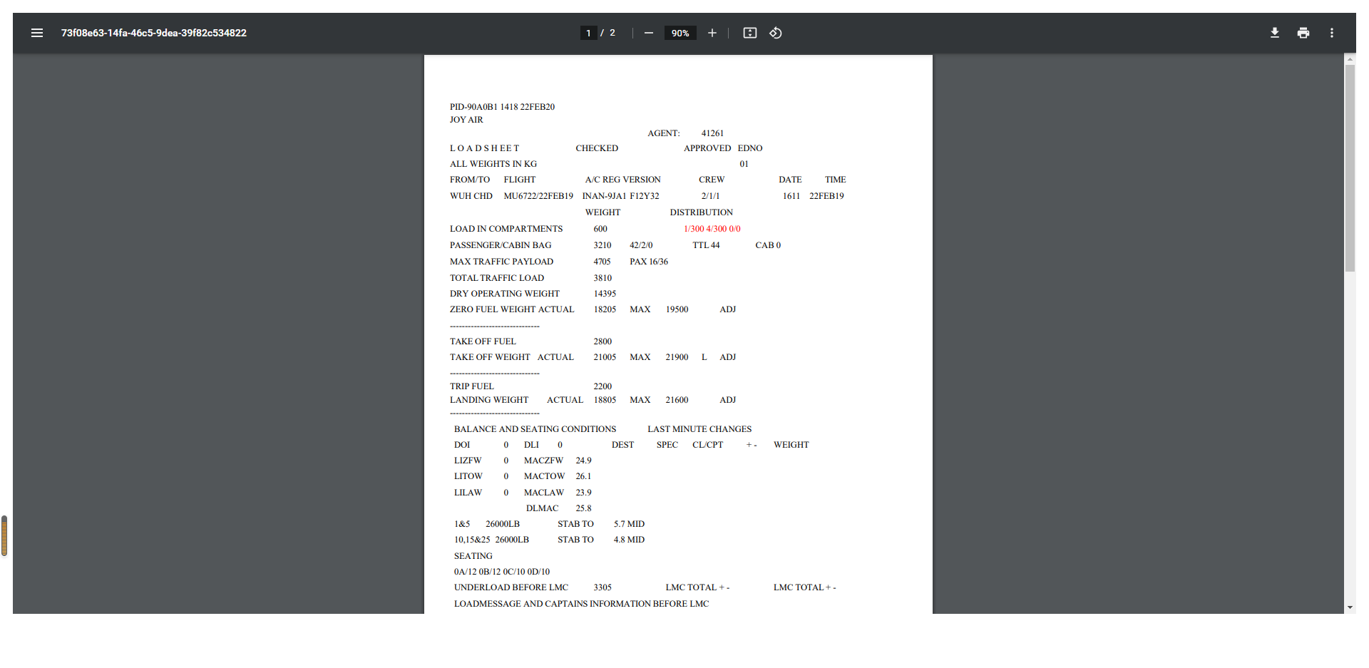

* 1. Data Anlysis and Statistic

Based on the aircraft flight information, the data anlysis and statistics functioin is mainly statistics and anlysis the number of flights and industry load saturation; this operation functioin is mainly viewed by the dispatcher and the business leadership.

The dispatcher and the business leadership select 【Data Analysis】 in the left menu tree to enter management main interface， picture this:

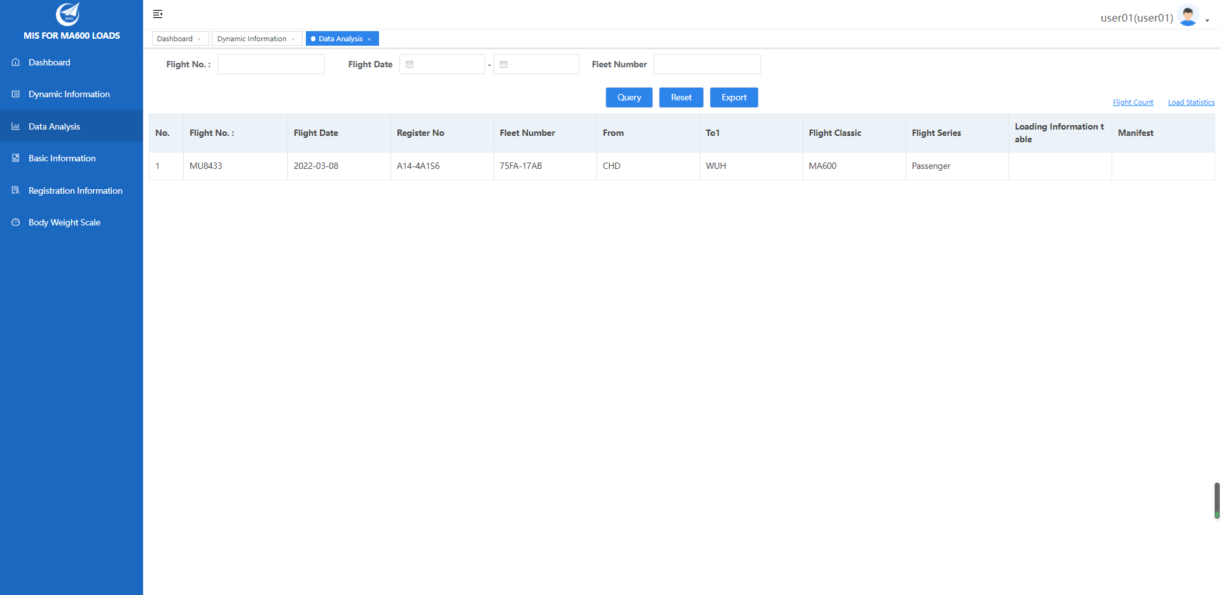

The dispatcher and the business leadership can input flight number, flight data, fleet number to fliter the flight record data. Click the 【Flight Count】 and 【Load Statistics】 link optioins in the upper right corner of the list， then the correrponding graphical analysis reports will display, picture this:

